Mach (aeronautica)

Da Wikipedia, l'enciclopedia libera.

Il Mach è un'unità di misura della velocità, utilizzata in aeronautica, che esprime il superamento della velocità del suono, e il cui valore è dato dal rapporto tra la velocità e la velocità del suono. Per esempio Mach = 1 significa viaggiare ad una velocità pari a quella del suono, Mach = 2 significa viaggiare al doppio della velocità del suono. La sua definizione deriva dall'espressione del numero di Mach per l'aria una volta che sia fissata la quota di volo.
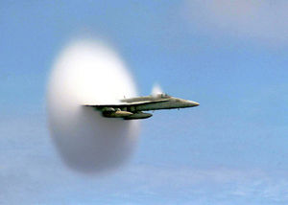
Un aereo nell'istante in cui supera la velocità del suono. Le due nuvolette coniche in coda e dietro l'abitacolo sono dovute al vapore acqueo, condensato istantaneamente dalla sovrapressione sul fronte dell'onda d'urto supersonica
Il suo nome deriva dal fisico Ernst Mach. Il valore esatto è leggermente variabile in funzione dell'altitudine, infatti la velocità di Mach 1,5 è pari a 1.830 km/h a livello del mare e ad 1.725 km/h a 1150 metri di quota.
Da quando fu misurata con precisione la velocità del suono, il suo superamento divenne un'ossessione. Fra il 1930 e il 1940, il tentativo di superarlo portò all'adeguamento della potenza dei motori e della struttura degli aeroplani.
L'attraversamento del muro del suono produce un caratteristico fragore (il bang sonico, simile ad un tuono) e vibrazioni potenzialmente pericolose, che possono anche provocare la distruzione dell'aereo se questo non è appositamente progettato.
Un aereo che viaggia ad una velocità inferiore a Mach = 1 si dice che viaggia a velocità subsonica, se è superiore a Mach = 1 si dice che viaggia a velocità supersonica, per valori di Mach vicini o superiori al 5 si parla di velocità ipersonica.
Gli aeroplani commerciali di linea viaggiano in genere poco sotto Mach 1, mentre la maggior parte degli aerei militari possono superarlo e arrivare a volte a Mach 2 o 3. Velocità fino a Mach 7 sono state raggiunte da apparecchi sperimentali.
Il primo uomo ad oltrepassare il muro del suono fu Charles "Chuck" Yaeger, il 14 ottobre 1947.

[modifica] Voci correlate
- Velocità supersonica
- numero di Mach
- regime subsonico
- regime transonico
- regime supersonico
- regime ipersonico

Categorie: Unità di velocità | Aeronautica
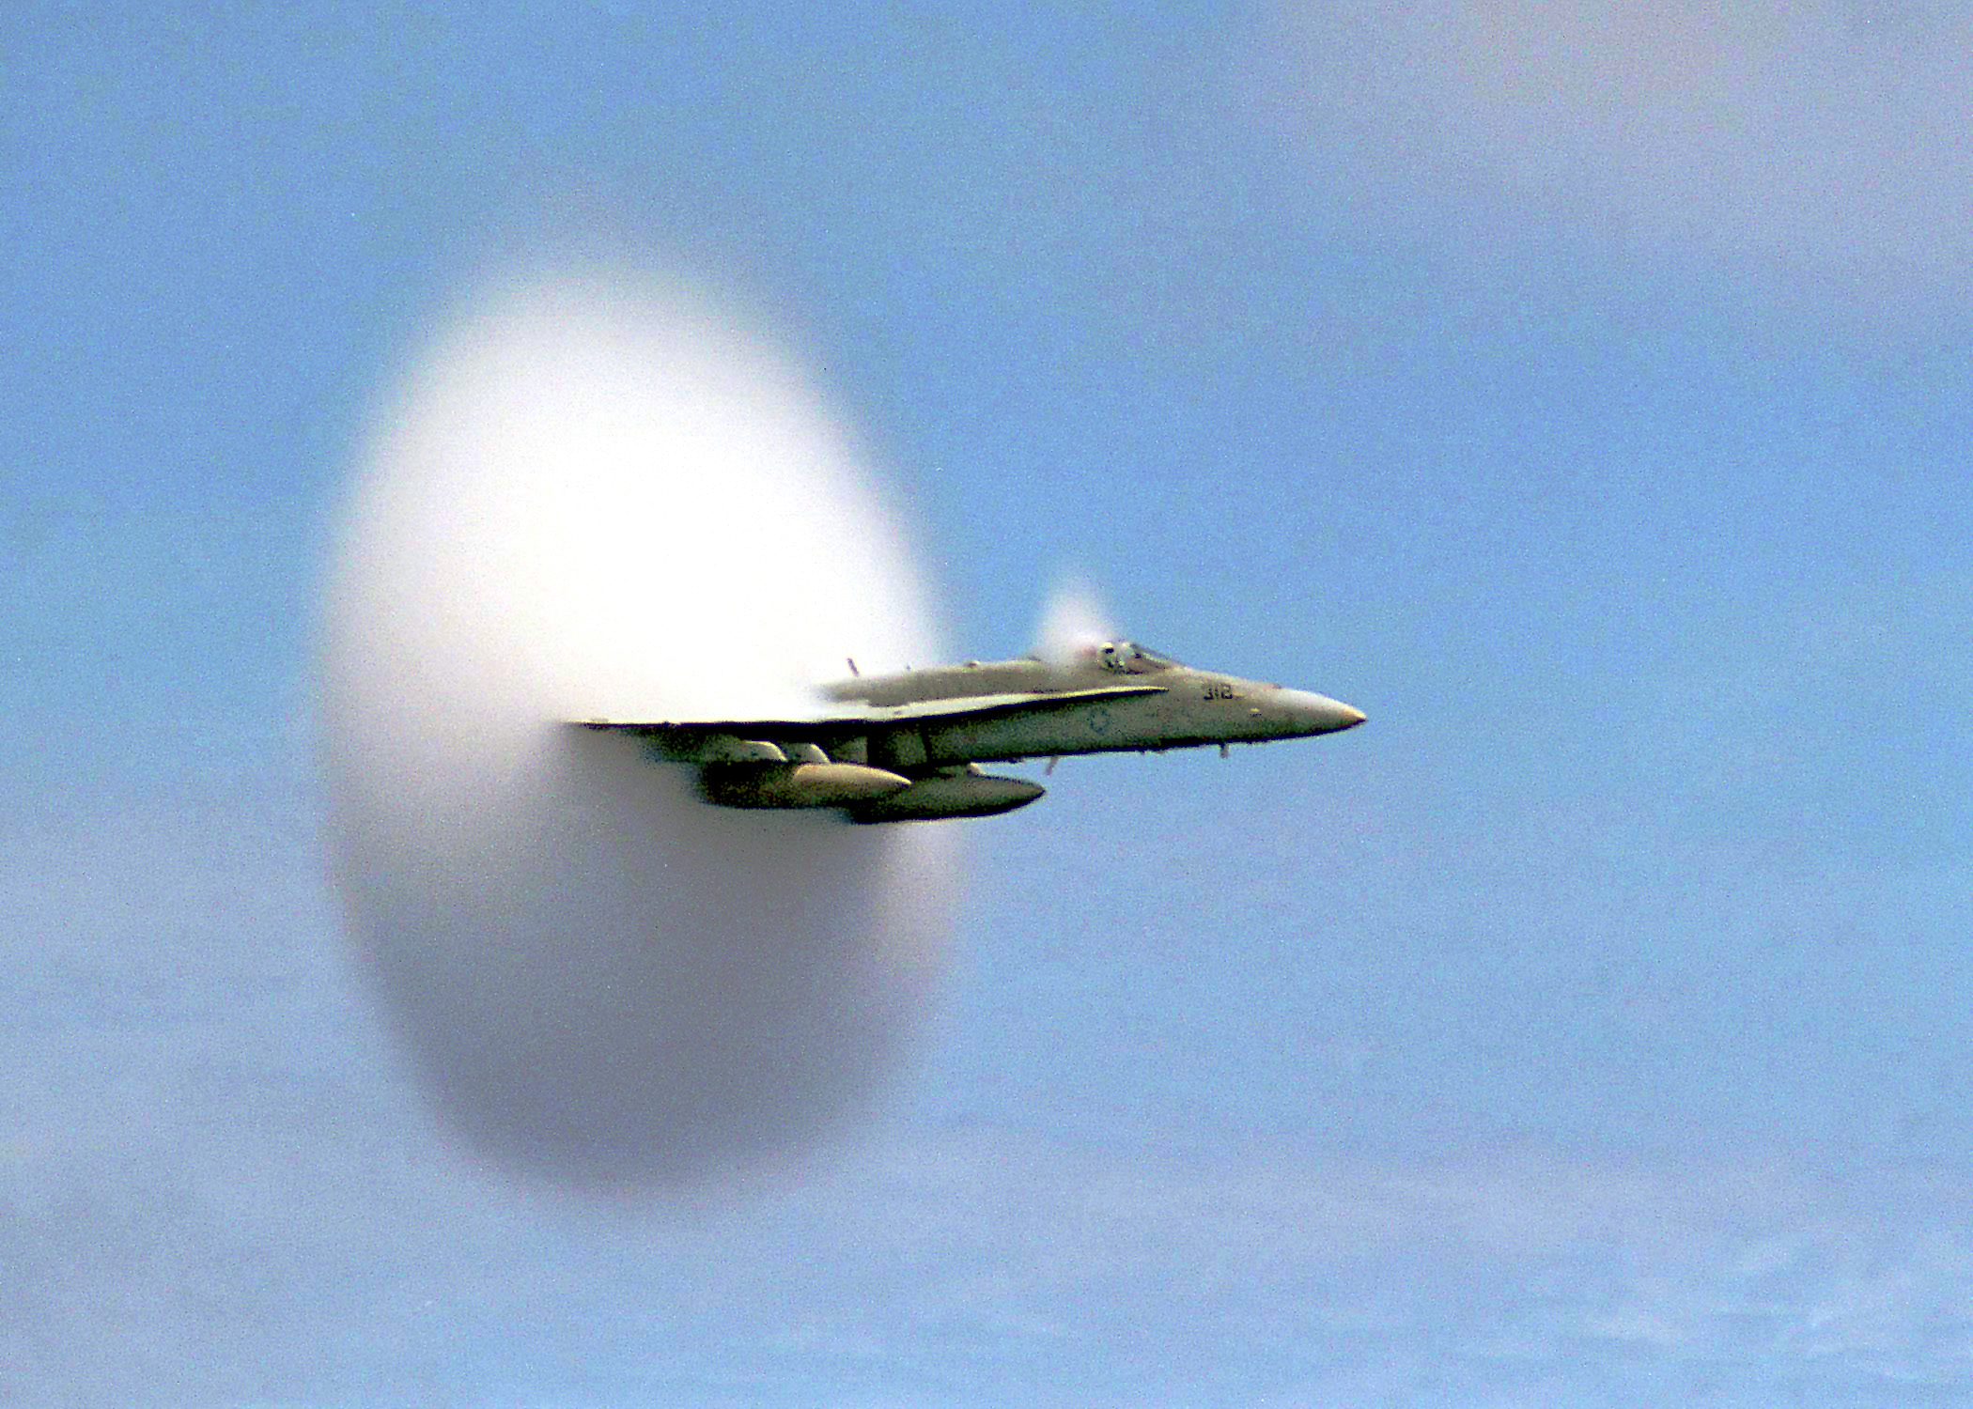

Mach number

From Wikipedia, the free encyclopedia
Jump to: navigation, search
Mach number (Ma) (pronounced: [mæk], [mɑːk]) is defined as a ratio of the speed of an object or flow relative to the speed of sound in the medium through which it is travelling:
v_{o}/v_{s}
where
v_{o} is the speed of the object and
v_{s} is the speed of sound in the medium
In other words, Mach is the number of times the speed of sound an object or wave moves.
The Mach number is named after Austrian physicist and philosopher Ernst Mach.

Contents
[hide]
- 1 Overview
- 2 High-speed flow around objects
- 3 High-speed flow in a channel
- 4 Instrumentation
- 5 External links
[edit]

Overview
The Mach number is commonly used both with objects travelling at high speed in a fluid, and with high-speed fluid flows inside channels such as nozzles, diffusers or wind tunnels. As it is defined as a ratio of two speeds, it is a dimensionless number. At a temperature of 15 degrees Celsius, Mach 1 is 340.3 m·s⁻¹ (1,225 km·h⁻¹ or 761.2 mph) in the atmosphere. The Mach number is not a constant; it is temperature dependent. Hence in the stratosphere it remains about the same regardless of height, though the air pressure changes with height.
Since the speed of sound increases as the temperature increases, the actual speed of an object travelling at Mach 1 will depend on the fluid temperature around it. Mach number is useful because the fluid behaves in a similar way at the same Mach number. So, an aircraft traveling at Mach 1 at sea level (340.3 m·s⁻¹, 1,225.08 km/h) will experience shock waves in much the same manner as when it is traveling at Mach 1 at 11,000 m (36,000 ft), even though it is travelling at 295 m·s⁻¹ (654.632 MPH, 1,062 km/h, 86% of its speed at sea level).
It can be shown that the Mach number is also the ratio of inertial forces (also referred to aerodynamic forces) to elastic forces.
[edit]

High-speed flow around objects
High speed flight can be classified in four categories:
- Subsonic: Ma < 1
- Transonic: 0.8 < Ma < 1.2
- Supersonic: 1.2 < Ma < 5
- Hypersonic: Ma > 5
(For comparison: the required speed for low Earth orbit is ca. 7.5 km·s⁻¹ = Ma 25.4 in air at high altitudes)
At transsonic speeds, the flow field around the object includes both sub- and supersonic parts. The transsonic regime begins when first zones of Ma>1 flow appear around the object. In case of an airfoil (such as an aircraft's wing), this typically happens above the wing. Supersonic flow can decelerate back to subsonic only in a normal shock; this typically happens before the trailing edge. (Fig.1a)
As the velocity increases, the zone of Ma>1 flow increases towards both leading and trailing edges. As Ma=1 is reached and passed, the normal shock reaches the trailing edge and becomes a weak oblique shock: the flow decelerates over the shock, but remains supersonic. A normal shock is created ahead of the object, and the only subsonic zone in the flow field is a small area around the object's leading edge. (Fig.1b)
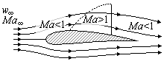 | 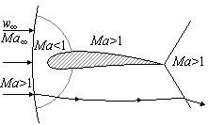
(a) | (b)
Fig. 1. Mach number in transsonic airflow around an airfoil; Ma<1 (a) and Ma>1 (b).
When an aircraft exceeds Mach 1 (i.e. the sound barrier) a large pressure difference is created just in front of the aircraft. This abrupt pressure difference, called a shock wave, spreads backward and outward from the aircraft in a cone shape (a so-called Mach cone). It is this shock wave that causes the sonic boom heard as a fast moving aircraft travels overhead. A person inside the aircraft will not hear this. The higher the speed, the more narrow the cone; at just over Ma=1 it is hardly a cone at all, but closer to a slightly concave plane.
At fully supersonic velocity the shock wave starts to take its cone shape, and flow is either completely supersonic, or (in case of a blunt object), only a very small subsonic flow area remains between the object's nose and the shock wave it creates ahead of itself. (In the case of a sharp object, there is no air between the nose and the shock wave: the shock wave starts from the nose.)
As the Mach number increases, so does the strength of the shock wave and the Mach cone becomes increasingly narrow. As the fluid flow crosses the shock wave, its speed is reduced and temperature, pressure, and density increase. The stronger the shock, the greater the changes. At high enough Mach numbers the temperature increases so much over the shock that ionization and dissociation of gas molecules behind the shock wave begin. Such flows are called hypersonic.
It is clear that any object travelling at hypersonic velocities will likewise be exposed to the same extreme temperatures as the gas behind the nose shock wave, and hence choice of heat-resistant materials becomes important.
[edit]

High-speed flow in a channel
As a flow in a channel crosses Ma=1 becomes supersonic, one significant change takes place. Common sense would lead one to expect that contracting the flow channel would increase the flow speed (i.e. making the channel narrower results in faster air flow) and at subsonic speeds this holds true. However, once the flow becomes supersonic, the relationship of flow area and speed is reversed: expanding the channel actually increases the speed.
The obvious result is that in order to accelerate a flow to supersonic, one needs a convergent-divergent nozzle, where the converging section accelerates the flow to Ma=1, sonic speeds, and the diverging section continues the acceleration. Such nozzles are called de Laval nozzles and in extreme cases they are able to reach incredible, hypersonic velocities (Mach 13 at sea level).
[edit]

Instrumentation
An aircraft Mach meter or electronic flight information system (EFIS) can display Mach number derived from stagnation pressure (pitot tube) and static pressure.
Assuming air to be a diatomic ideal gas and for subsonic compressible flow:
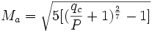
where
q_{c} is impact pressure and
P is static pressure.
[edit]

External links
- Gas Dynamics Toolbox Calculate Mach number and normal shock wave parameters for mixtures of perfect and imperfect gases.
- NASA's page on Mach Number Calculate Mach number.
Retrieved from "http://en.wikipedia.org/wiki/Mach_number"
Categories: Fluid dynamics | Dimensionless numbers | Aerodynamics

Sound barrier

From Wikipedia, the free encyclopedia
Jump to: navigation, search
It has been suggested that Sonic boom be merged into this article or section. (Discuss)
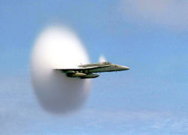
U.S. Navy F/A-18 at transonic speed. The cloud is due to the Prandtl-Glauert singularity.
This is an article about the aviation term. For the 1952 film see The Sound Barrier (film). For the heavy metal band, see Sound Barrier.
In aerodynamics, the sound barrier is the transition at transonic speeds from subsonic to supersonic travel (usually refers to flight). The Sound Barrier was once believed to be a physical barrier preventing large objects from traveling faster than sound. The term came into use during World War II when a number of aircraft started to encounter the effects of compressibility, a grab-bag of unrelated aerodynamic effects, and fell out of use in the 1950s when aircraft started to routinely "break" the sound barrier.

[edit] History of breaking the sound barrier
The bullwhip or stockwhip was probably the first human-made object to move faster than sound. The tip of the whip breaks the sound barrier and causes a sharp crack--literally a sonic boom. Many forms of ammunition also achieve supersonic speeds.
The tip of the propeller on many World War II aircraft may reach supersonic speeds, producing a noticeable buzz that differentiates such aircraft. This is particularly noticeable on the Stearman, and noticeable on the T-6 Texan when it enters a sharp-breaking turn. Note that this is in fact undesireable as the transonic air movement creates disruptive shock waves and turbulance.
The sound barrier was first broken in a vehicle in a sustained way on land in 1948 by a rocket-powered test vehicle at Muroc Air Force Base (now Edwards AFB) in California. It was powered by 50,000 pounds of thrust, reaching 1,019 mph [1].
For human flight, it is believed that several fighter aircraft of the Second World War, in particular the Supermarine Spitfire, exceeded the sound barrier while diving. However, because it is likely that getting close to this speed in these aircraft would cause the aircraft to become uncontrollable and crash, none of the pilots of these flights would have survived, leaving the tale unsolved.
Why the loss of control? The increased speed caused a shockwave to form on the wing and tail, and as the speed increases this shock wave moves back along the wing and tail. This changes the pressure distribution on the aerodynamic surfaces, and can reverse the effect of the ailerons and elevators. It was this effect that is thought to have caused the crash which killed Geoffrey de Havilland Jr, in the middle of flight testing the DH.108, de Havilland Swallow. The flights were close to or possibly achieved the speed of sound, but since they ended in tragedy, it was in no way useful to the advancement of supersonic flight.
In 1942 the United Kingdom's Ministry of Aviation began a top secret project with Miles Aircraft to develop the world's first aircraft capable of breaking the sound barrier. The project resulted in the development of the prototype Miles M.52 jet aircraft, which was designed to reach 1,000 mph (417 m/s; 1,600 km/h) at 36,000 feet (11 km) in 1 minute 30 seconds.
The aircraft's design was revolutionary introducing many innovations which are still used on today's supersonic aircraft. The single most important development was the all-moving tailplane giving extra control to counteract the Mach tuck which allowed control to be maintained at supersonic speeds; this was the brainchild of Dennis Bancroft and his team at Miles Research. The project was cancelled by the Director of Scientific Research, Sir Ben Lockspeiser, before any piloted flights were conducted. Subsequently, on government orders, all design data and research regarding the Miles M.52 was sent to BELL aircraft in the USA. There was an agreement for data exchange in both directions, but, after receiving the British data, the American government blocked the deal. Later experimentation on the Miles M.52 design proved that the aircraft would indeed have broken the sound barrier, with an unpiloted 3/10 scale replica of the M.52 achieving Mach 1.5 in October 1948.
Hans Guido Mutke claimed to have broken the sound barrier before Yeager, on April 9, 1945 in a Messerschmitt Me 262. However, this claim is widely disputed by most experts as the Me 262's stucture could not support high transonic, let alone supersonic, flight and thus this claim lacks a plausible scientific foundation.
George Welch made a plausible but officially unverified claim to have broken the sound barrier on October 1, 1947 while flying an F-86 Sabre. He also claimed to have repeated his supersonic flight on October 14, 1947, 30 minutes before Chuck Yeager broke the sound barrier in the Bell X-1 using the adjustable tail concept. Although evidence from witnesses and instruments strongly imply that Welch achieved supersonic speed, the flights were not properly monitored and cannot be officially recognized. (The XP-86 officially achieved supersonic speed on April 26, 1948.)
Chuck Yeager was the first person to break the sound barrier in level flight on October 14, 1947, flying the experimental Bell X-1 at Mach 1 at an altitude of 45,000 feet (13.7 km).
Jackie Cochran was the first woman to break the sound barrier on May 18, 1953 in a Canadair F-86 Sabre.
Although the Concorde and Tu-144 were certainly the first aircraft to carry commercial passengers at supersonic speeds, they were not the first or only commercial airliners to break the sound barrier. On August 21, 1961 a Douglas DC-8 broke the sound barrier at Mach 1.012 or 660 mph while in a controlled dive through 41,088 feet. The purpose of the flight was to collect data on a new leading-edge design for the wing.[2] Boeing reports that the 747 broke the sound barrier during certification tests. A China Airlines 747 almost certainly broke the sound barrier in an unplanned descent from 41 000 feet to 9500 feet after an in-flight upset on 19 February 1985. It also reached over 5g. [3]
On October 15, 1997, in a vehicle designed and built by a team led by Richard Noble, driver Andy Green became the first person to break the sound barrier in a land vehicle. The vehicle called the ThrustSSC ("Super Sonic Car"), captured the record almost exactly 50 years after Yeager's flight.

[edit] External links

Wikimedia Commons has media related to:
Sound barrier
- Sound Barrier. Archived from the original on 2005-02-18. a tutorial from the Sonic Boom, Sound Barrier, and Condensation Clouds. Archived from the original on 2005-02-18. (or "Sonic Boom, Sound Barrier, and Prandtl-Glauert Condensation Clouds") collection of tutorials by Mark S. Cramer, Ph.D. at Tutorials, Sound Barrier. Archived from the original on 2005-02-18. (Tutorials, Sound Barrier.)
- "Breaking the Sound Barrier with an Aircraft" by Carl Rod Nave, Ph.D. at http://HyperPhysics.phy-astr.gsu.edu (Sound).
- "[4]" a video of a concorde reaching mach 1 at intersection TESGO taken from below.
Retrieved from "http://en.wikipedia.org/wiki/Sound_barrier"
Categories: Articles to be merged since September 2006 | Aviation

Shock wave

From Wikipedia, the free encyclopedia
Jump to: navigation, search
This article is about a type of disturbance. For other senses of the word, see shockwave (disambiguation).
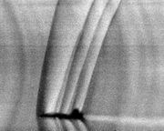
Schlieren photograph of shock waves produced by a T-38 Talon during flight.
A shock wave (or simply "shock") is a type of propagating disturbance. Like a normal wave, a shock wave carries energy and can propagate through a medium or, in special cases, through a field such as the electromagnetic field in the absence of a physical medium. Shock waves are characterized by a sudden change in the characteristics of the medium (such as pressure, temperature, or speed) as a positive step function. The corresponding negative step is an expansion wave. An acoustic shock wave travels through most mediums at a higher speed than a normal wave.
Unlike solitons (another kind of nonlinear wave), the energy of a shock wave dissipates relatively quickly with distance. Additionally, the companion expansion wave from a shock approaches, and eventually merges with the shock, partially cancelling it out. Thus the sonic boom associated with the passage of an aircraft is the sound wave resulting from the degradation and merging of the shock wave-expansion wave pair produced by the passage of a supersonic aircraft.

Contents
[hide]
- 1 Shock waves in supersonic flows
- 2 Shock waves due to nonlinear steepening
- 3 Analogies
- 4 Types of shock wave
- 5 External links
- 6 See also

[edit] Shock waves in supersonic flows
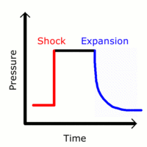
Pressure-time diagram at a point for a shock wave propagating past the observer
The shock wave is one of several different ways in which a gas in a supersonic flow can be compressed. Two other methods are isentropic and Prandtl-Meyer compressions. The method of compression of a gas results in different temperatures and densities for a given pressure ratio, which can be analytically calculated for a non-reacting gas. A shock wave compression results in a loss of total pressure, meaning that it is a less efficient method of compressing gases for some purposes, for instance in the intake of a scramjet. The appearance of pressure-drag on supersonic aircraft is mostly due to the effect of shock compression on the flow.
When an object (or disturbance) moves faster than the information about it can be propagated into the surrounding fluid, fluid near the disturbance cannot react or "get out of the way" before the disturbance arrives. In a shock wave the properties of the fluid (density, pressure, temperature, velocity, Mach number) change almost instantaneously. Measurements of the thickness of shock waves have resulted in values approximately one order of magnitude greater than the mean free path of the gas investigated.
Shock waves are not sound waves; a shock wave takes the form of a very sharp change in the gas properties on the order of a few mean free paths (roughly micro-meters at atmospheric conditions) in thickness. Shock waves in air are heard as a loud "crack" or "snap" noise. Over time a shock wave can change from a nonlinear wave into a linear wave, degenerating into a conventional sound wave as it heats the air and loses energy. The sound wave is heard as the familiar "thud" or "thump" of a sonic boom, commonly created by the supersonic flight of aircraft.

[edit] Shock waves due to nonlinear steepening
Shock waves can form due to steepening of ordinary waves. The best-known example of this phenomenon is ocean waves that form breakers on the shore. In shallow water, the speed of surface waves is dependent on the depth of the water. An incoming ocean wave has a slightly higher wave speed near the crest of each wave than near the troughs between waves, because the wave height is not infinitesimal compared to the depth of the water. The crests overtake the troughs until the leading edge of the wave forms a vertical face and spills over to form a turbulent shock (a breaker) that dissipates the wave's energy as sound and heat.
Similar phenomena affect strong sound waves in gas or plasma, due to the dependence of the sound speed on temperature and pressure. Strong waves heat the medium near each pressure front, due to adiabatic compression of the air itself, so that high pressure fronts outrun the corresponding pressure troughs. While shock formation by this process does not normally happen to sound waves in Earth's atmosphere, it is thought to be one mechanism by which the solar chromosphere and corona are heated, via waves that propagate up from the solar interior.

[edit] Analogies
A shock wave may be described as the furthest point upstream of a moving object which "knows" about the approach of the object. In this description, the shock wave position is defined as the boundary between the zone having no information about the shock-driving event, and the zone aware of the shock-driving event, analogous with the light cone described in the theory of general relativity.
To get a shock wave something has to be travelling faster than the local speed of sound. In that case some parts of the air around the aircraft are travelling at exactly the speed of sound with the aircraft, so that the soundwaves leaving the aircraft pile up on each other, similar to a tailback on a road, and a shock wave forms, the pressure goes up and up and up there, and then spreads out sideways. Because of this amplification effect, a shock wave is very intense, more like an explosion when you hear it (not coincidentally, since explosions create shock waves).
Analogous phenomena are known outside fluid mechanics. For example, particles accelerated beyond the speed of light in a refractive medium (where the speed of light is less than that in a vacuum, such as water) create visible shock effects, a phenomenon known as Cherenkov radiation.

[edit] Types of shock wave
There are several types of shock wave:
- Shock propagating into a stationary flow
  - This shock is generally generated by the interaction of two bodies of gas at different pressure, with a shock wave propagating into the lower pressure gas, and an expansion wave propagating into the higher pressure gas.
  - Examples: Balloon bursting, Shock tube, shock wave from explosion
  - In this case, the gas ahead of the shock is stationary (in the laboratory frame), and the gas behind the shock is supersonic in the laboratory frame. The shock propagates normal to the oncoming flow. The speed of the shock is a function of the original pressure ratio between the two bodies of gas.
- Shock in a pipe flow
  - This shock appears when supersonic flow in a pipe is decelerated.
  - Examples: Supersonic ramjet, scramjet, needle valve
  - In this case the gas ahead of the shock is supersonic (in the laboratory frame), and the gas behind the shock system is either supersonic (oblique shocks) or subsonic (normal shock) (Although for some oblique shocks very close to the deflection angle limit, the downstream Mach number is subsonic.) The shock is the result of the deceleration of the gas by a converging duct, or by the growth of the boundary layer on the wall of a parallel duct.
- Re-compression shock on a transonic body
  - These shocks appear when the flow over a transonic body is decelerated to subsonic speeds.
  - Examples: Transonic wings, turbines
  - Where the flow over the suction side of a transonic wing is accelerated to a supersonic speed, the resulting re-compression can be by either Prandtl-Meyer compression or by the formation of a normal shock. This shock is of particular interest to makers of transonic devices because it can cause separation of the boundary layer at the point where it touches the transonic profile. This can then lead to full separation and stall on the profile, higher drag, or shock-buffet, a condition where the separation and the shock interact in a resonance condition, causing resonating loads on the underlying structure.
- Attached shock on a supersonic body
  - These shocks appear as "attached" to the tip of a sharp body moving at supersonic speeds.
  - Examples: Supersonic wedges and cones with small apex angles
  - The attached shock wave is a classic structure in aerodynamics because, for a perfect gas and inviscid flow field, an analytic solution is available, such that the pressure ratio, temperature ratio, angle of the wedge and the downstream Mach number can all be calculated knowing the upstream Mach number and the shock angle. Smaller shock angles are associated with higher downstream Mach numbers, and the special case where the shock wave is at 90 degrees to the oncoming flow (Normal shock), is associated with a downstream Mach number of one. These follow the "weak-shock" solutions of the analytic equations.
- Detached shock on a supersonic body (see also bow shock)
  - Such a shock occurs about a supersonic body that is too blunt for the shock to attach to the tip.
  - Examples: Space return vehicles (Apollo, Space shuttle), bullets, the boundary of a magnetosphere
  - These shocks are curved, and form a small distance in front of the body. Directly in front of the body, they stand at 90 degrees to the oncoming flow, and then curve around the body. Detached shocks allow the same type of analytic calculations as for the attached shock, for the flow near the shock. They are a topic of continuing interest, because the rules governing the shock's distance ahead of the blunt body are complicated, and are a function of the body's shape. Additionally, the shock standoff distance varies drastically with the temperature for a non-ideal gas, causing large differences in the heat transfer to the thermal protection system of the vehicle. See the extended discussion on this topic at Atmospheric reentry. These follow the "strong-shock" solutions of the analytic equations, meaning that for some oblique shocks very close to the deflection angle limit, the downstream Mach number is subsonic.
- Detonation wave
  - A detonation wave is essentially a shock within which an exothermic reaction takes place. It involves a wave traveling through a highly combustible or chemically unstable medium, such as an oxygen-methane mixture or a high explosive. The chemical reaction of the medium occurs within the wave, and the chemical energy of the reaction drives the wave forward.
  - It is also possible for a shock wave in a reactive mixture to initiate combustion (shock-induced combustion), but in this case the shock proceeds at a velocity indicated by the non-combusted mixture, since the actual combustion occurs in the region behind the shock wave, rather than within the wave. The velocity of a shock wave is independent of what is happening after it passes.
  - A detonation wave follows slightly different rules from an ordinary shock since it is driven by the chemical reaction occurring inside the wave front itself. This change from a shock-induced combustion to detonation happens as the time for the exothermic reaction to occur approaches the time for the shock-wave to pass the reacting particles. Detonation waves proceed at the Chapman-Jouguet velocity, which is a function of the nature of the chemical reaction occurring. A detonation will also cause a shock of type 1, above to propagate into the surrounding air due to the overpressure induced by the explosion.

[edit] External links
- Photo Gallery
- eFluids gallery
- NACA 1135: Equations, Tables, and Charts for Compressible Flow
- Bomb Shock Wave Estimation
- NASA Glenn Research Center information on:
  - Oblique Shocks
  - Multiple Crossed Shocks
  - Expansion Fans
- Selkirk college: Aviation intranet: High speed (supersonic) flight
  - Energy loss in a shock wave, normal and oblique shock waves
  - Formation of a normal shock wave

[edit] See also
- Sonic boom
- Mach wave
- Magnetopause
- Atmospheric reentry
Retrieved from "http://en.wikipedia.org/wiki/Shock_wave"
Category: Fluid dynamics


